**Experiment 2:**

Step1**:** Design a logo on paper with a pencil.

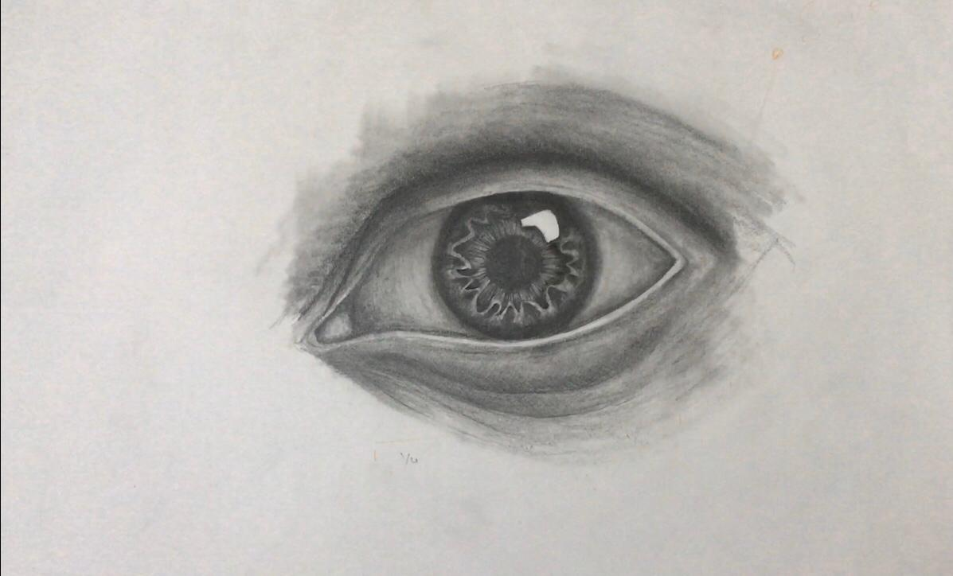

Step2**:** Open GIMP and click on New → Open as layer and open the image as above.

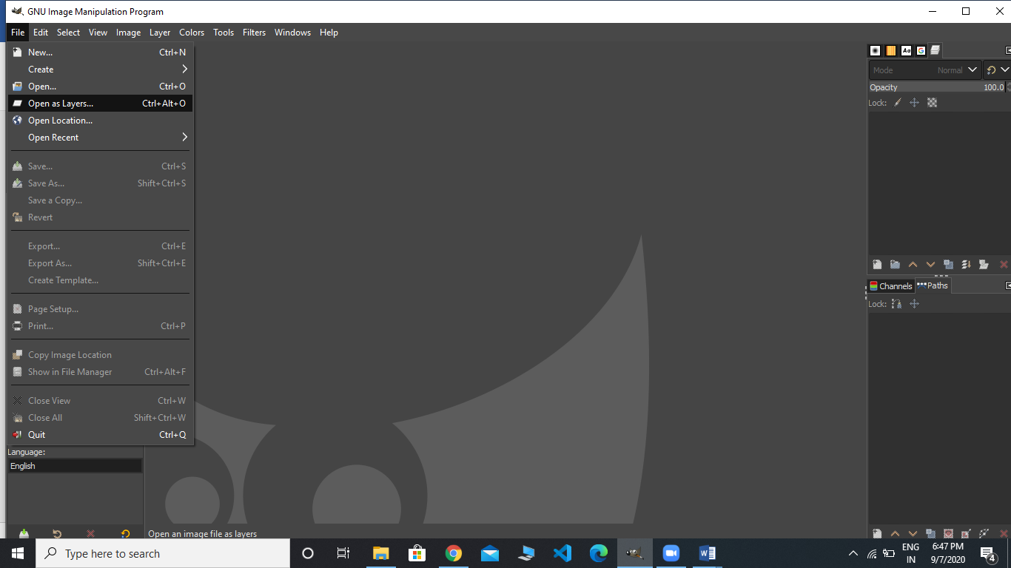

**Step3:** The image can now be edited using GIMP, add the text using TEXT TOOL under the toolbox. Add other objects.

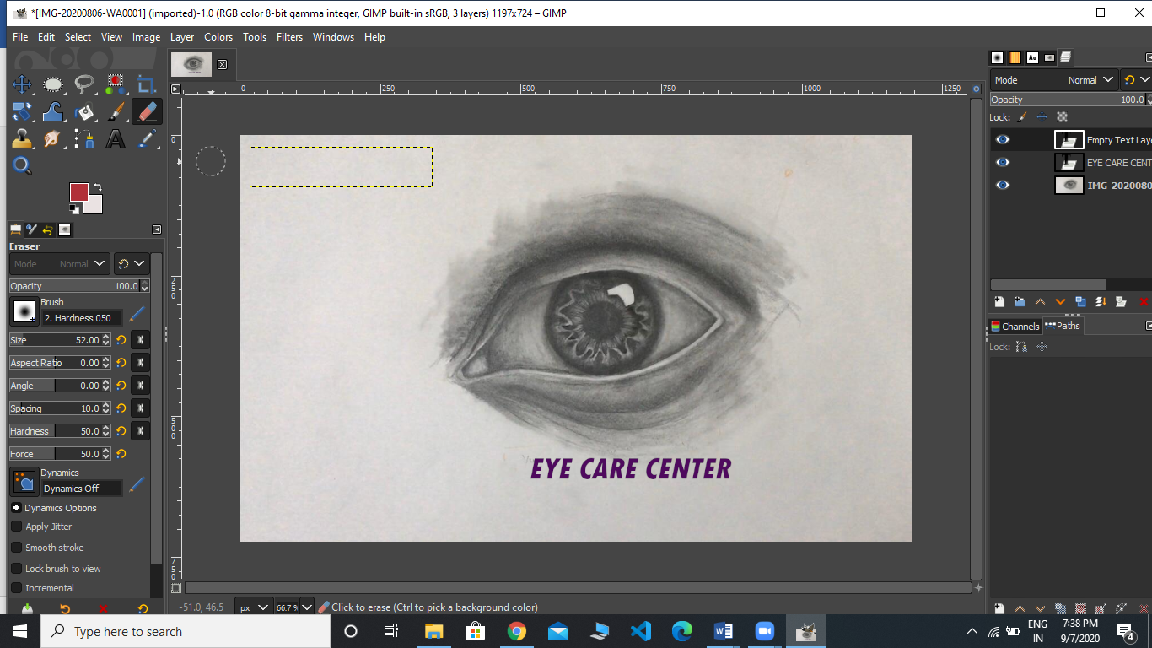

**Step4:** Export the image as .PNG or .JPG.